**Wavelet KAN FULL - with Mexican Hat**

3:36:57<00:00, 130.18s/epoch, Loss: 0.2760 Accuracy: 89.97

Final Test Loss: 2.4254

Test Accuracy: 51.18%

Model FLOPs: 8750208

Maximum VRAM Usage: 5.44 GB

Model Parameters: 154740

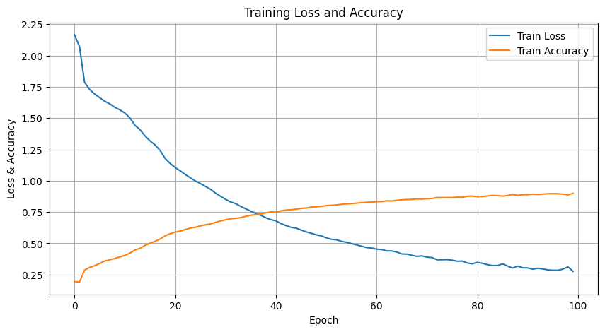

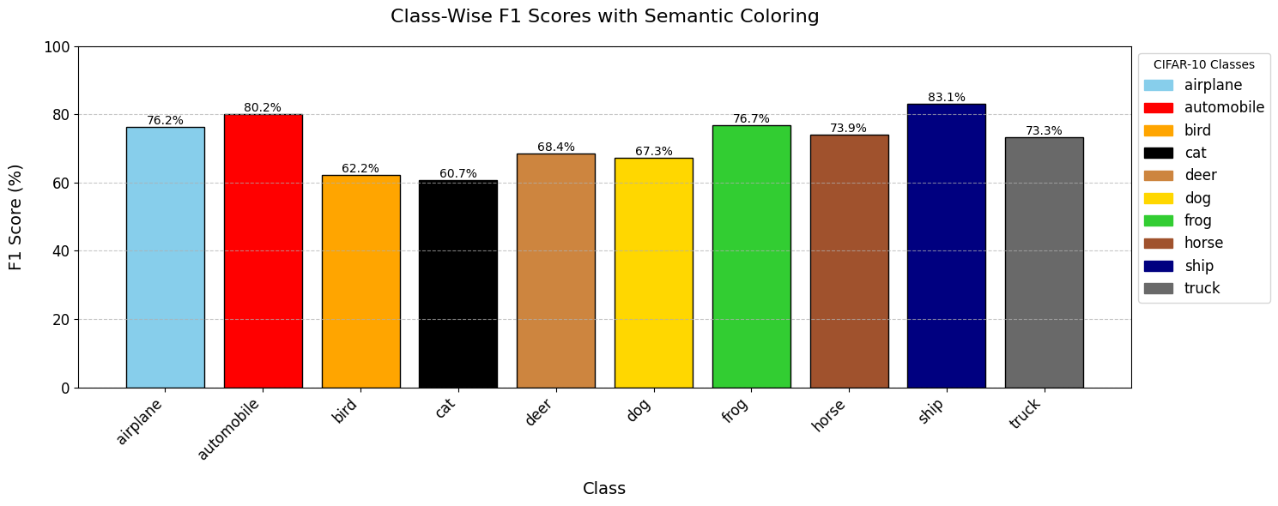

Class-Wise Performance:

airplane : Precision=74.32%, Recall=78.28%, F1=76.25%

automobile : Precision=81.42%, Recall=78.92%, F1=80.15%

bird : Precision=67.47%, Recall=57.66%, F1=62.18%

cat : Precision=61.52%, Recall=59.91%, F1=60.70%

deer : Precision=71.57%, Recall=65.48%, F1=68.39%

dog : Precision=66.19%, Recall=68.40%, F1=67.28%

frog : Precision=73.27%, Recall=80.49%, F1=76.71%

horse : Precision=71.78%, Recall=76.23%, F1=73.94%

ship : Precision=83.47%, Recall=82.82%, F1=83.14%

truck : Precision=71.66%, Recall=75.09%, F1=73.34%

**Wavelet KAN Head + MLP Encoder**

20:16<00:00, 12.16s/epoch, Loss: 0.2779 Accuracy: 89.88

Final Test Loss: 2.1435

Test Accuracy: 57.45%

Maximum VRAM Usage: 0.13 GB

Model FLOPs: 8750208

Model Params: 55796

Class-Wise Performance:

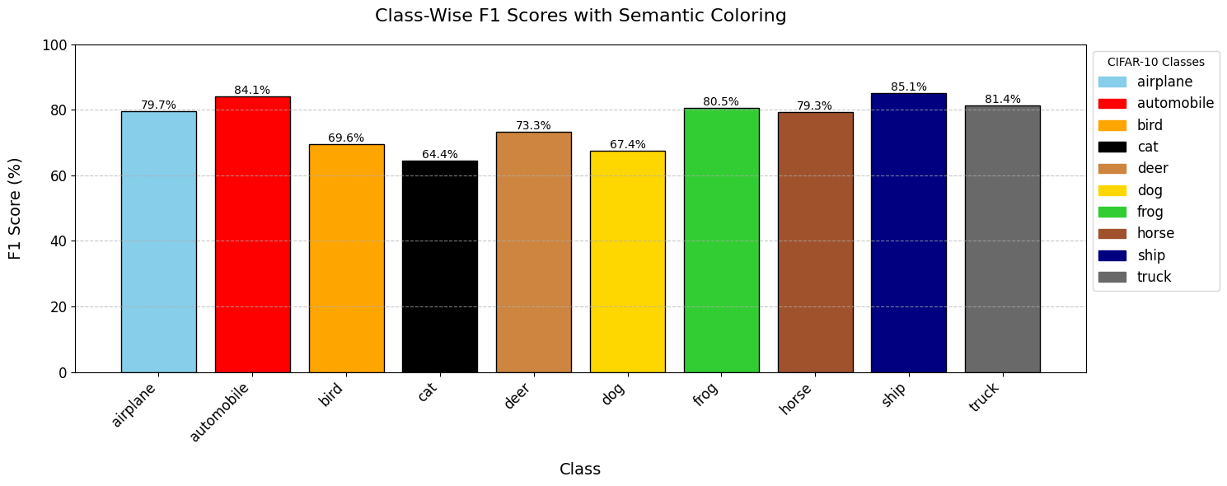

airplane : Precision=79.46%, Recall=79.92%, F1=79.69%

automobile : Precision=83.44%, Recall=84.71%, F1=84.07%

bird : Precision=70.99%, Recall=68.25%, F1=69.59%

cat : Precision=65.12%, Recall=63.70%, F1=64.40%

deer : Precision=73.71%, Recall=72.89%, F1=73.30%

dog : Precision=67.87%, Recall=66.97%, F1=67.42%

frog : Precision=79.03%, Recall=82.05%, F1=80.52%

horse : Precision=79.02%, Recall=79.64%, F1=79.33%

ship : Precision=84.59%, Recall=85.65%, F1=85.11%

truck : Precision=81.16%, Recall=81.57%, F1=81.36%

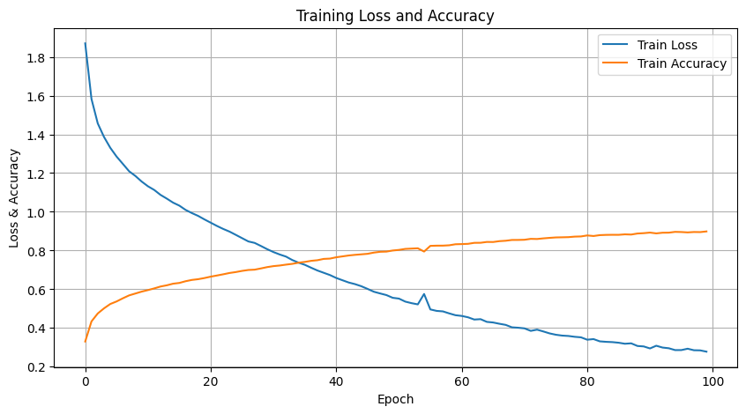

**Wavelet KAN Head + KAN Encoder**

1:37:47<00:00, 58.67s/epoch, Loss: 0.1435 Accuracy: 94.93

Model Parameters: 350068

Final Test Loss: 2.7129

Test Accuracy: 54.29%

Maximum VRAM Usage: 1.64 GB

Model FLOPs: 42828928

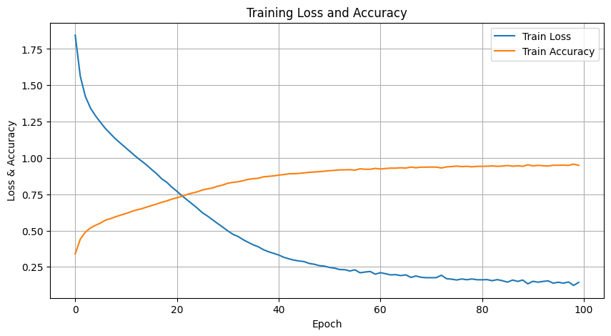

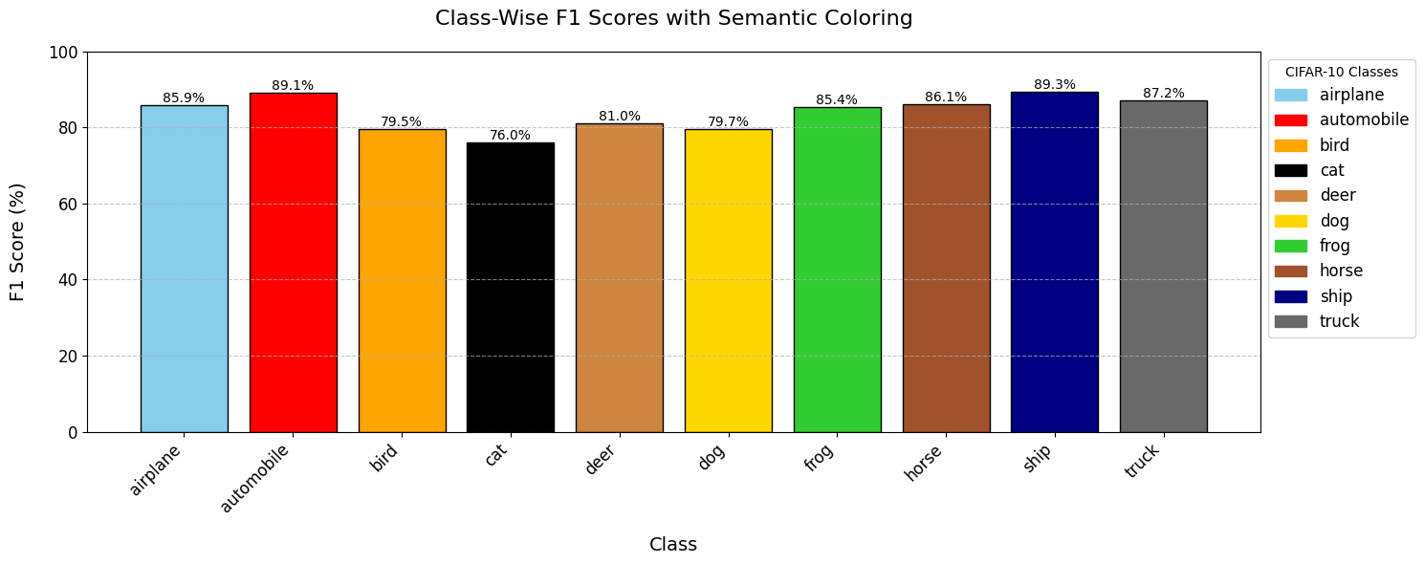

Class-Wise Performance:

airplane : Precision=85.84%, Recall=85.98%, F1=85.91%

automobile : Precision=88.72%, Recall=89.57%, F1=89.14%

bird : Precision=80.38%, Recall=78.59%, F1=79.48%

cat : Precision=76.47%, Recall=75.52%, F1=75.99%

deer : Precision=81.42%, Recall=80.59%, F1=81.00%

dog : Precision=80.22%, Recall=79.15%, F1=79.68%

frog : Precision=84.39%, Recall=86.34%, F1=85.35%

horse : Precision=85.82%, Recall=86.45%, F1=86.13%

ship : Precision=88.87%, Recall=89.73%, F1=89.30%

truck : Precision=86.90%, Recall=87.50%, F1=87.20%

**MLP VIT FULL**

16:25<00:00, 9.86s/epoch, Loss: 0.3052 Accuracy: 88.73

Final Test Loss: 2.5515

Test Accuracy: 54.23%

Maximum VRAM Usage: 0.13 GB

Model FLOPs: 8750208

Class-Wise Performance:

airplane : Precision=78.01%, Recall=77.90%, F1=77.95%

automobile : Precision=81.07%, Recall=82.93%, F1=81.99%

bird : Precision=69.38%, Recall=65.87%, F1=67.58%

cat : Precision=63.47%, Recall=61.54%, F1=62.49%

deer : Precision=70.89%, Recall=70.42%, F1=70.66%

dog : Precision=66.61%, Recall=65.68%, F1=66.14%

frog : Precision=76.61%, Recall=80.31%, F1=78.42%

horse : Precision=78.34%, Recall=78.76%, F1=78.55%

ship : Precision=82.75%, Recall=84.47%, F1=83.60%

truck : Precision=79.11%, Recall=79.56%, F1=79.34%

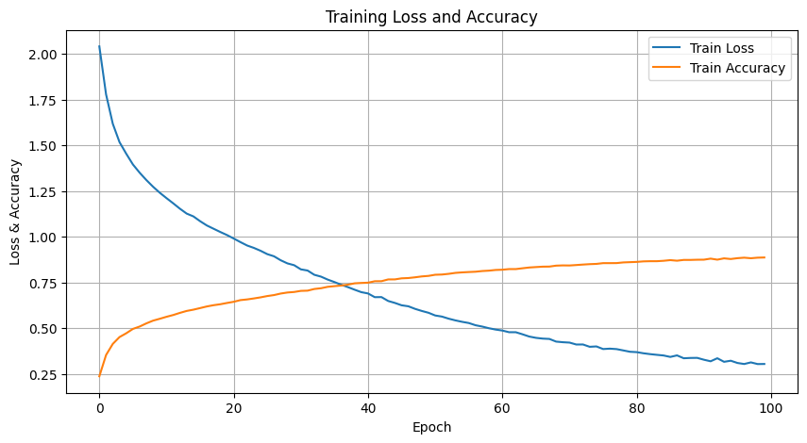

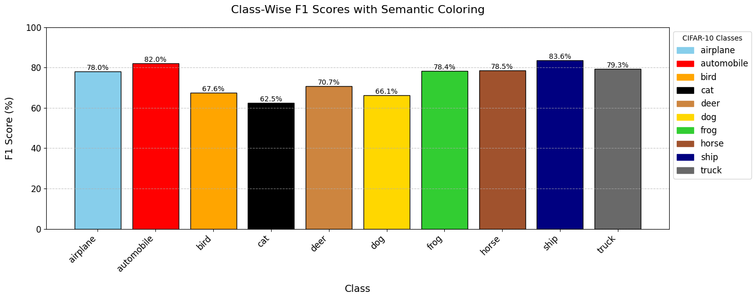

**WAVELET KAN FULL - with DoG**

3:04:34<00:00, 110.75s/epoch, Loss: 0.2103 Accuracy: 92.26

Final Test Loss: 2.6186

Test Accuracy: 53.32%

Maximum VRAM Usage: 5.44 GB

Model FLOPs: 8750208

Class-Wise Performance:

airplane : Precision=82.76%, Recall=83.51%, F1=83.13%

automobile : Precision=87.57%, Recall=88.04%, F1=87.81%

bird : Precision=74.83%, Recall=72.70%, F1=73.75%

cat : Precision=73.43%, Recall=71.14%, F1=72.27%

deer : Precision=75.90%, Recall=74.74%, F1=75.32%

dog : Precision=76.31%, Recall=75.49%, F1=75.90%

frog : Precision=81.81%, Recall=84.77%, F1=83.26%

horse : Precision=83.18%, Recall=84.60%, F1=83.89%

ship : Precision=86.47%, Recall=87.35%, F1=86.91%

truck : Precision=85.24%, Recall=85.90%, F1=85.57%

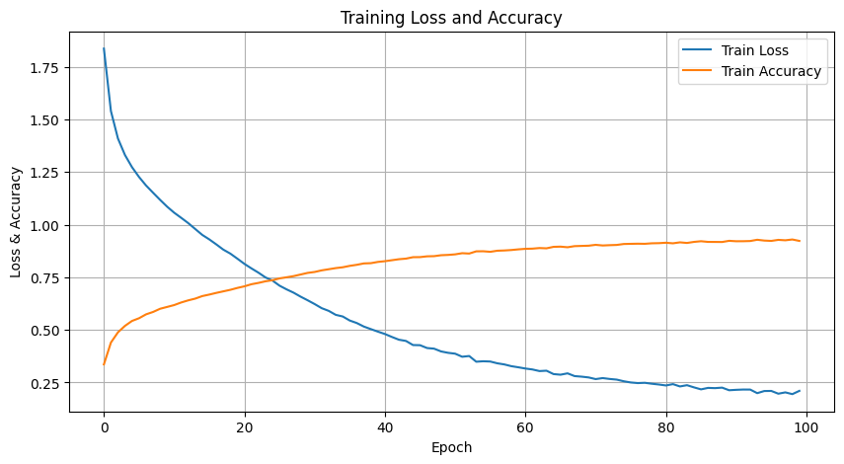

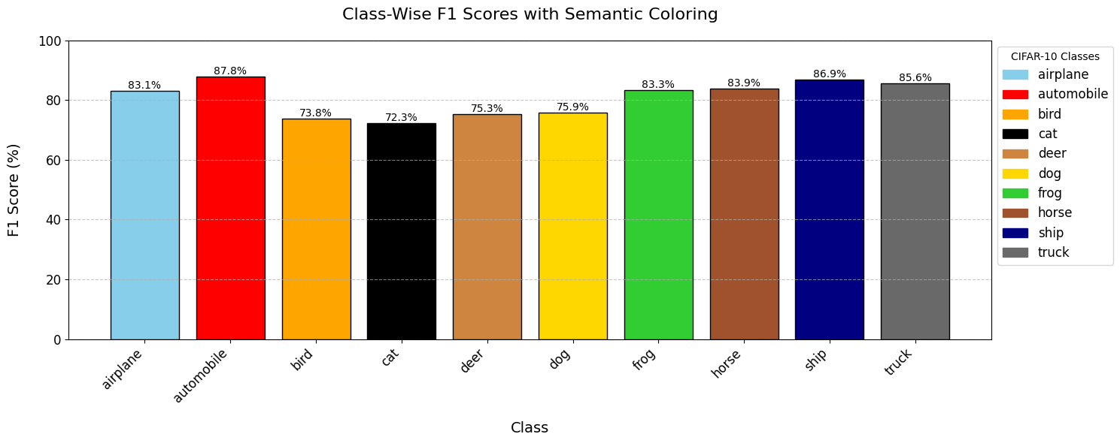

**KAN Head + Wavelet KAN Encoder**

3:05:28<00:00, 111.29s/epoch, Loss: 0.2253 Accuracy: 91.83

Final Test Loss: 2.6364

Test Accuracy: 53.02%

Maximum VRAM Usage: 5.44 GB

Model FLOPs: 8755328

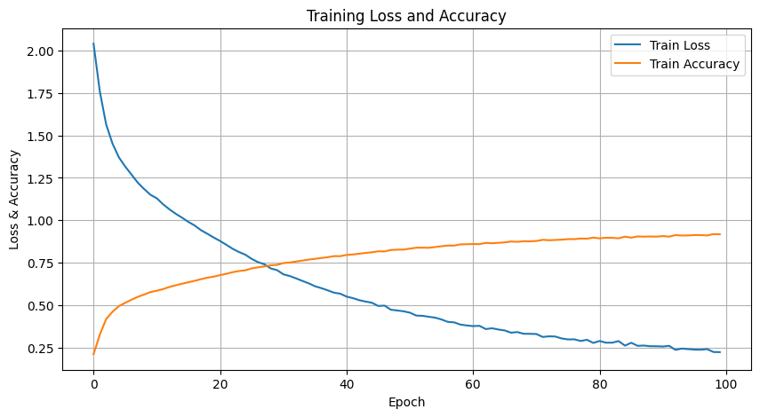

Class-Wise Performance:

airplane : Precision=81.72%, Recall=82.45%, F1=82.08%

automobile : Precision=85.96%, Recall=85.91%, F1=85.93%

bird : Precision=72.23%, Recall=66.29%, F1=69.13%

cat : Precision=65.87%, Recall=66.54%, F1=66.20%

deer : Precision=72.46%, Recall=73.45%, F1=72.95%

dog : Precision=70.16%, Recall=68.15%, F1=69.14%

frog : Precision=80.94%, Recall=84.31%, F1=82.59%

horse : Precision=82.66%, Recall=82.80%, F1=82.73%

ship : Precision=85.32%, Recall=87.06%, F1=86.18%

truck : Precision=82.79%, Recall=84.03%, F1=83.41%

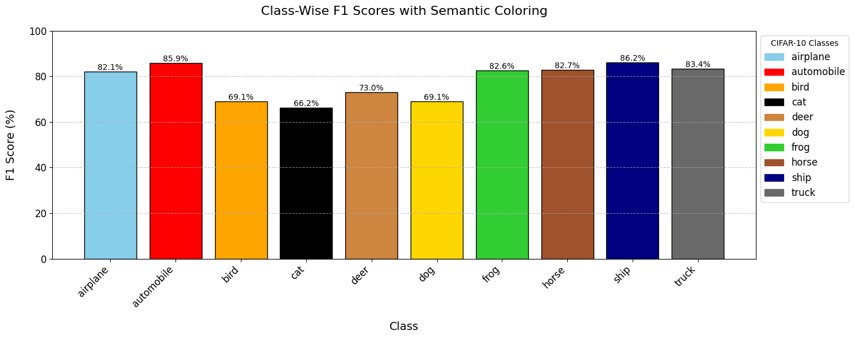

**KAN Head + MLP Encoder**

17:33<00:00, 10.54s/epoch, Loss: 0.3290 Accuracy: 87.99

Final Test Loss: 2.3802

Test Accuracy: 54.90%

Model Parameters: 57696

Maximum VRAM Usage: 0.13 GB

Model FLOPs: 8755328

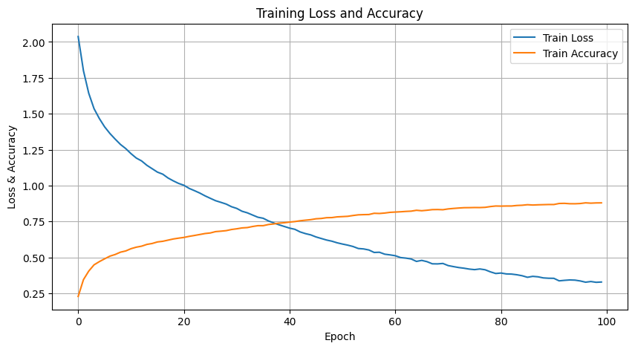

Class-Wise Performance:

airplane : Precision=78.09%, Recall=78.23%, F1=78.16%

automobile : Precision=81.20%, Recall=82.12%, F1=81.66%

bird : Precision=68.90%, Recall=63.81%, F1=66.26%

cat : Precision=62.49%, Recall=60.94%, F1=61.71%

deer : Precision=69.70%, Recall=69.13%, F1=69.41%

dog : Precision=66.71%, Recall=65.61%, F1=66.16%

frog : Precision=75.32%, Recall=79.52%, F1=77.36%

horse : Precision=77.27%, Recall=78.56%, F1=77.91%

ship : Precision=82.20%, Recall=84.12%, F1=83.15%

truck : Precision=78.41%, Recall=79.55%, F1=78.97%

